Slotted Aloha

1. It was developed just to improve the efficiency of pure aloha as the chances for collision in pure aloha are high.
2. The time of the shared channel is divided into discrete time intervals called slots.
3. Sending of data is allowed only at the beginning of these slots.
4. If a station misses out the allowed time, it must wait for the next slot. This reduces the probability of collision.
5. 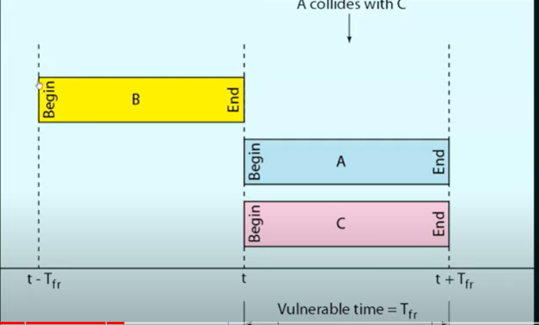
6. 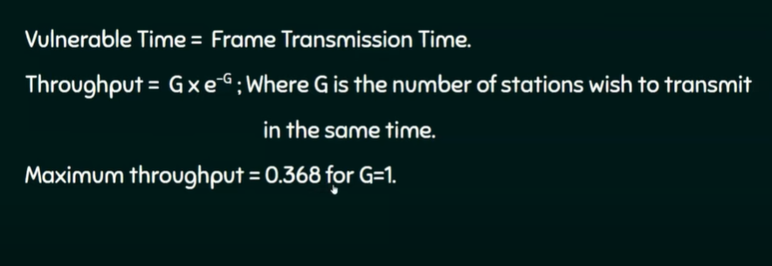
7. 